**ASSIGNMENT NO: 6**

**Title:-**Doubly linklist

**Problem Statement:-**The ticket booking of cinemax theatre has to be implemented by using C++ program.There are 10 rows and 7 seats in each row.Doubly circular link list has to be implemented to be keep a track to free seats at rows .Assume some random booking to start with use array to store head pointer of each row on demand.

1) The list of available seats to be displayed.

2) Seats are to be booked.

3) Booking can be canceled.

**Learning Objectives:**

-Difference between linear, circular link list.

-All related operations of doubly link list.

**Pre-requisites:**

Linear link list and pointers.

**Theory:**

A doubly linked list is a linked data structure that consists of a set of sequentially linked records called nodes. Each node contains two fields, called links, that are references to the previous and to the next node in the sequence of nodes.

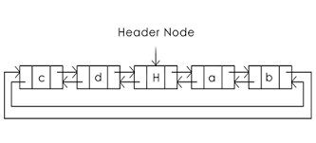

Creation of DLL:-

Class DLL node

{

Public:

Int data;

DLL node *prev *next;

DLL node()

{

Prev=next=NULL;

}

};

*Insertion of node in DLL:

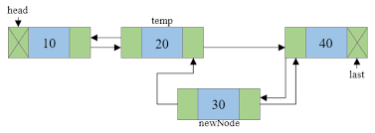

Node 1->next=current

Node 2->previous=current

Current->next=node 2

Current->previous=node

*Insertion before first node

Current->next=head

Head->previous=current

Head=current

Current->previous=NULL

*Deletion of node from DLL

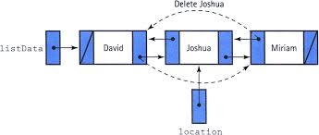

(current->prev)->next=current->next

(current->next)->prev=current->prev

Delete current

*Traversal of DLL

-Advantage of DLL is that 2 pointers are used to previous and next node so list can be traversed in forward backward direction.

-If we have circular DLL it has more advantage than SLL

Head=node->data

If(node->next=NULL)

End of list